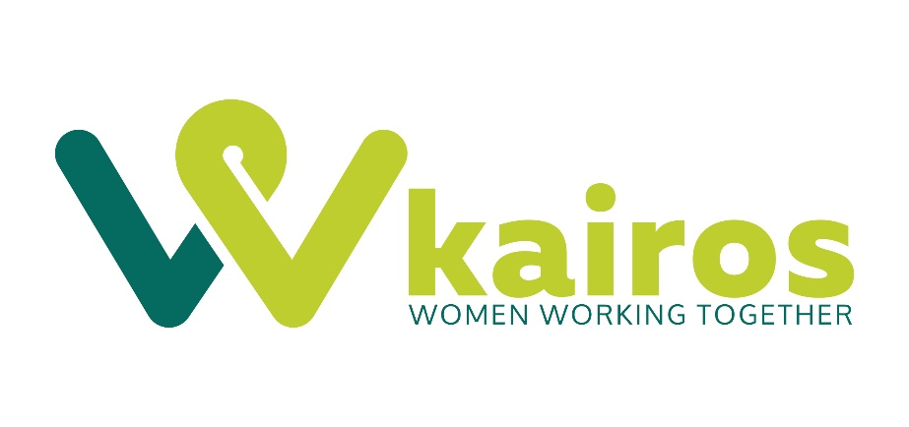

Fundraising & Research Internship Application Form

Thank you for your interest in volunteering with KairosWWT as Fundraising and Research intern. Please fill in the application form as fully as you can.

NB: This role is partially based at KairosWWT offices, which acts as a Drop-In for service users to have a women-only safe space. The role will involve some contact with service users through training/induction at different Kairos projects. For these reasons, the fundraising intern role is only open to female candidates. Please contact the office on 02476 559550 if you have any queries.

Your contact Details

Name:
Address:

Postcode:
Email Address
Phone | Daytime |  | Evening
 | Mobile

Your Experience

a. | Why do you want to apply for the internship position, and why with KairosWWT?  (max 300 words)
b. | Please outline how you meet the candidate requirements listed in the internship role description (max 300 words)
c. | What experience do you bring to the role (please include details of any relevant paid or unpaid role you have had)? (max 500 words)
d. | Please tell us about any qualifications you hold, or training you have received.

Your Availability
Please indicate by which days and times you are available to volunteer by ticking the relevant boxes. Please note the internship work must be carried out over one day of the week, or two half days of the week. Days worked are to be agreed in advance with the Kairos Director.
Day | Mon | Tues | Wed | Thurs | Fri
Morning (9am – 12pm) | ☐ | ☐ | ☐ | ☐ | ☐
Afternoon (12pm – 5pm) | ☐ | ☐ | ☐ | ☐ | ☐
Notes:
Please use the box to give us any specifics on your availability

References
Please provide contact details for two people who would be happy to provide a reference for you:

Name |  |  | Name
Address |  |  | Address
Contact Number |  |  | Contact Number
Email |  |  | Email

Accessibility and reasonable adjustments:

Kairos is committed to equality and diversity and ensuring our application process is fair and open to as many people as possible. Do you require any reasonable adjustments for the application and interview process, or the internship itself?

Please tick: Yes ☐ No ☐

If yes, please share relevant details:

Volunteering application process
If you have any difficulties completing this application form please contact Kairos on 02476 559550 or email rosie@kairoswwt.org.uk. If you would like to find out more about KairosWWT before applying, visit our website www.kairoswwt.org.uk or contact us on the above number.

Once we have received your form, we will contact you to invite you to attend an interview. If you are then accepted to become a KairosWWT volunteer, you will attend mandatory training as well as training relevant to your role.

Please note that two references will be required before the final offer can be made to the successful candidate.

Declaration – please read
I understand and agree that data contained in this registration form will be used for volunteer registration purposes and will be held on a computer database. I also agree to KairosWWT holding this form in paper format in a secure area.
I confirm that the information I have given is true and that if any statements I have given are not true, or if I have missed out any important information, my volunteering placement could be stopped. I also confirm that I know of no reason why I should not be suitable to volunteer with KairosWWT.
☐ | I agree to the above declaration
☐ | I also give my consent to receive other communications by email from Kairos outside those which directly relate to any volunteering placement(s) I may undertake. This includes opportunities to support marketing campaigns, attend information evening events, fundraising, and project updates. (please note – if you do not tick this box it does not exclude you from becoming a volunteer)

Please return your form by email to rosie@kairoswwt.org.uk or you can print and post it to:
FAO: Rosie Hart, Kairos WWT, St Peter’s Centre, Charles Street, Coventry, CV1 5NP

Privacy Statement:
KairosWWT collects personal information about you when you apply for a paid, or voluntary position with us, make a donation, or when you register with us as a Service User. We will use this information to provide the services requested, fulfil our obligations under a contract, manage donations, or correspond with you. For more information explaining how we use your information please request our Privacy Policy.

If you would like to, please fill in the Equality Monitoring Form which follows on the next page

Equality and diversity monitoring form

KairosWWT wants to meet the aims and commitments set out in its equality policy. This includes not discriminating under the Equality Act 2010, and building an accurate picture of the make-up of the work and volunteer force in encouraging equality and diversity.

The organisation needs your help and co-operation to enable it to do this, but filling in this form is voluntary.

The information you provide will stay confidential, and be stored securely and limited to only some staff in the organisation. This sheet will be detached from your Registration form and will remain anonymous and confidential.

Gender Male ☐ Female ☐ Prefer not to say ☐
Age 18-24 ☐ 25-29 ☐ 30-34 ☐ 35-39 ☐ 40-44 ☐ 45-49 ☐ 50-54 ☐ 55-59 ☐ 60-64 ☐ 65+ ☐ Prefer not to say ☐
What is your ethnicity?
Ethnic origin is not about nationality, place of birth or citizenship. It is about the group to which you perceive you belong. Please tick the appropriate box:
Asian/Asian British
Indian ☐ Pakistani ☐ Bangladeshi ☐ Chinese ☐ Prefer not to say ☐
Any other Asian background, please write in:

Black/ African/ Caribbean/ Black British
African ☐ Caribbean ☐ Prefer not to say ☐
Any other Black/African/Caribbean background, please write in:

Mixed/multiple ethnic groups
White and Black Caribbean ☐ White and Black African ☐ White and Asian ☐ Prefer not to say ☐ Any other mixed background, please write in:

White
English ☐ Welsh ☐ Scottish ☐ Northern Irish ☐ Irish ☐
British ☐ Gypsy or Irish Traveller ☐ Prefer not to say ☐
Any other white background, please write in:

Other ethnic group
Arab ☐ Prefer not to say ☐ Any other ethnic group, please write in:
Do you consider yourself to have a disability or health condition?
Yes ☐ No ☐ Prefer not to say ☐
The information in this form is for monitoring purposes only. If you believe you need a ‘reasonable adjustment’, then please discuss this when applying.
What is your sexual orientation?
Heterosexual ☐ Gay woman/lesbian ☐ Bisexual ☐
Prefer not to say ☐ If other, please write in:

What is your religion or belief?
No religion or belief ☐ Buddhist ☐ Christian ☐ Hindu☐ Jewish ☐
Muslim ☐ Sikh ☐ Prefer not to say ☐ If other religion or belief, please write in:
What is your current working pattern?
Full-time ☐ Part-time ☐ Prefer not to say ☐

Do you have caring responsibilities? If yes, please tick all that apply
None ☐
Primary carer of a child/children (under 18) ☐
Primary carer of disabled child/children ☐
Primary carer of disabled adult (18 and over) ☐
Primary carer of older person ☐
Secondary carer (another person carries out the main caring role) ☐
Prefer not to say ☐

